 | 

Faculty of Technology and Engineering
Chandubhai S. Patel Institute of Technology (CSPIT) Department of Computer Science & Engineering
Date: / /
Laboratory Manul

Academic Year | : | 2026-27 | Semester | : | 3rd
Course code | : | ITUE203 | Course name | : | WEB DEVELOPMENT FRAMEWORKS

Practical – 1
PROBLEM STATEMENT :

Objective :

Code :

Screenshot :

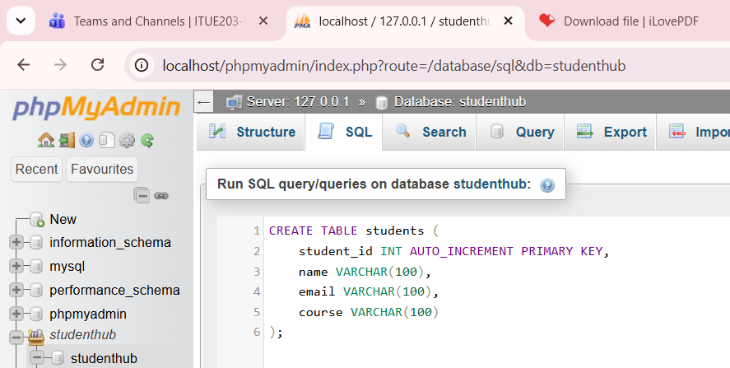
CREATE TABLE students (
student_id INT AUTO_INCREMENT PRIMARY KEY,
name VARCHAR(100),
email VARCHAR(100),
course VARCHAR(100)
);

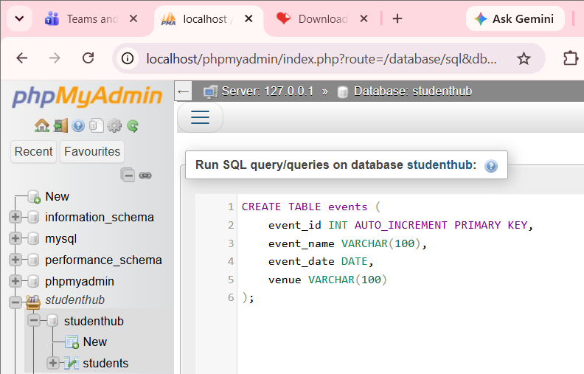
CREATE TABLE events (
event_id INT AUTO_INCREMENT PRIMARY KEY,
event_name VARCHAR(100),
event_date DATE,
venue VARCHAR(100)
);

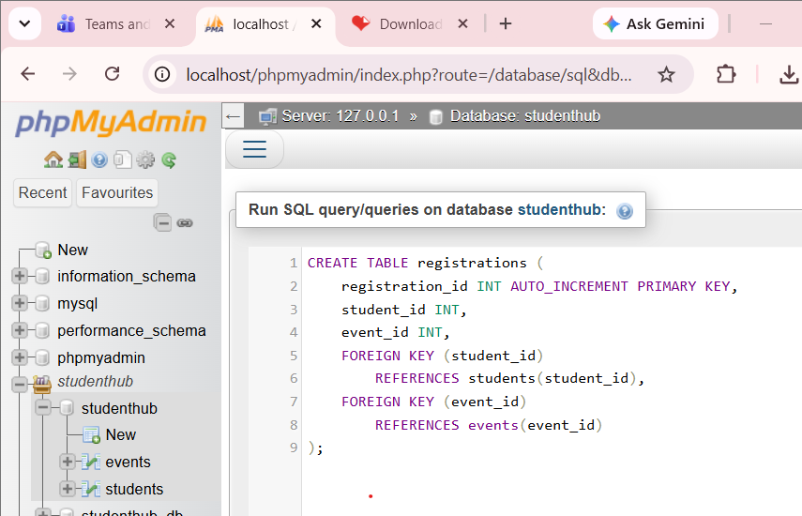
CREATE TABLE registrations (
registration_id INT AUTO_INCREMENT PRIMARY KEY,
student_id INT,
event_id INT,
FOREIGN KEY (student_id)
REFERENCES students(student_id),
FOREIGN KEY (event_id)
REFERENCES events(event_id)
);
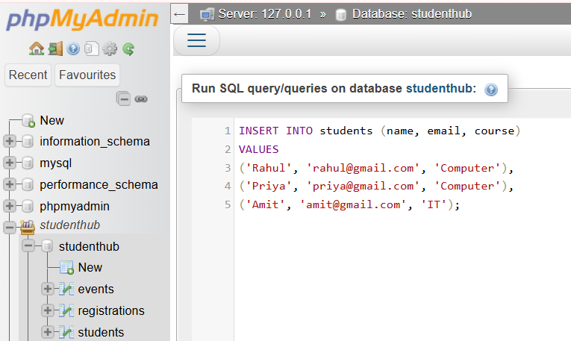
INSERT INTO students (name, email, course)
VALUES
('Rahul', 'rahul@gmail.com', 'Computer'),
('Priya', 'priya@gmail.com', 'Computer'),
('Amit', 'amit@gmail.com', 'IT');

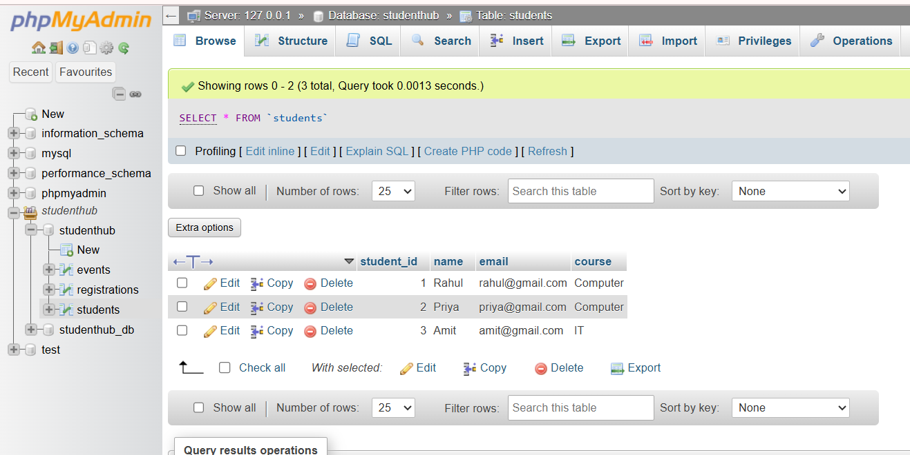
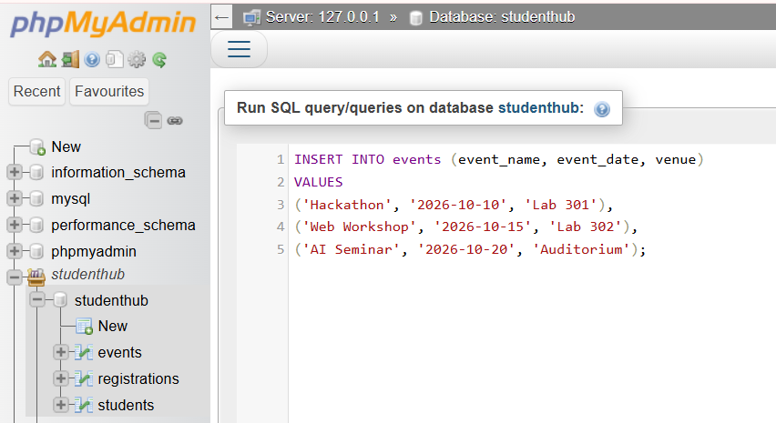
INSERT INTO events (event_name, event_date, venue)
VALUES
('Hackathon', '2026-10-10', 'Lab 301'),
('Web Workshop', '2026-10-15', 'Lab 302'),
('AI Seminar', '2026-10-20', 'Auditorium');

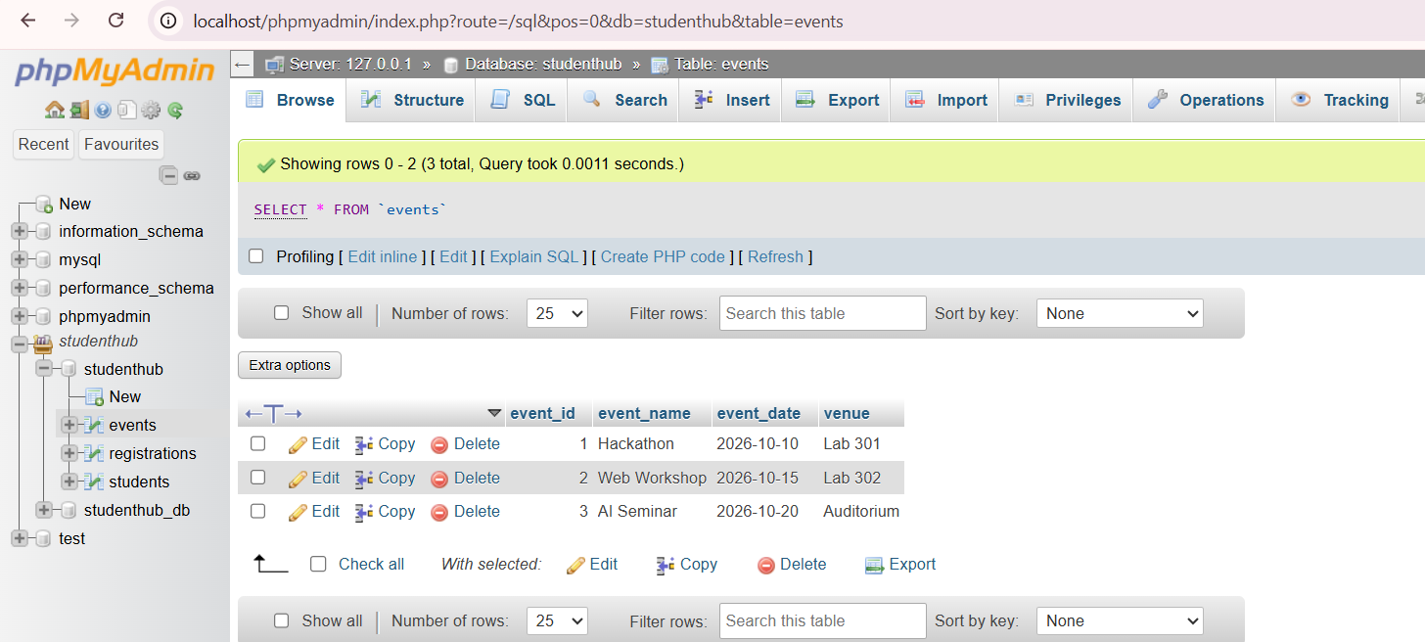
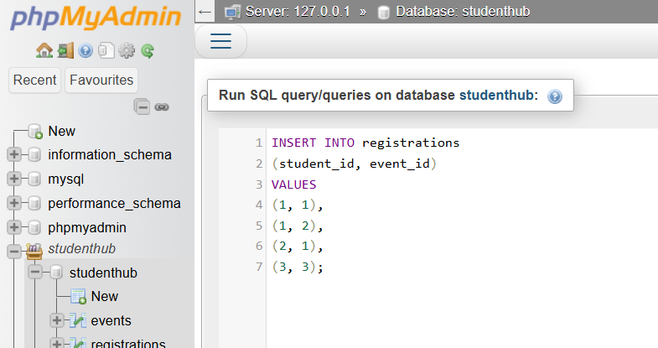
INSERT INTO registrations
(student_id, event_id)
VALUES
(1, 1),
(1, 2),
(2, 1),
(3, 3);

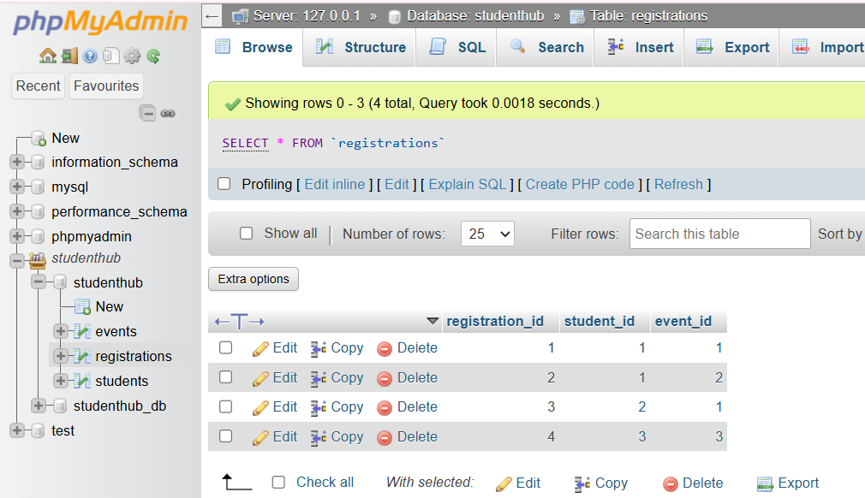

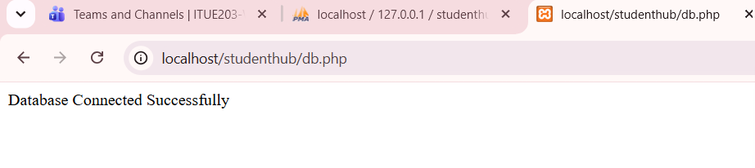

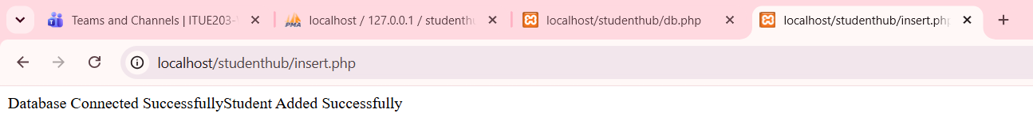

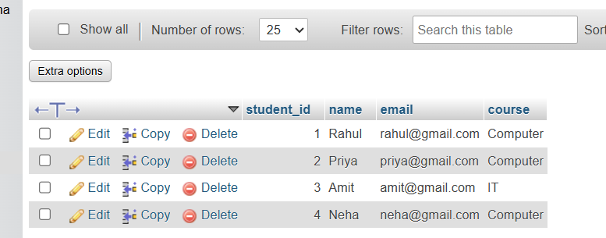

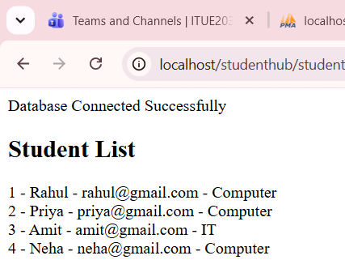

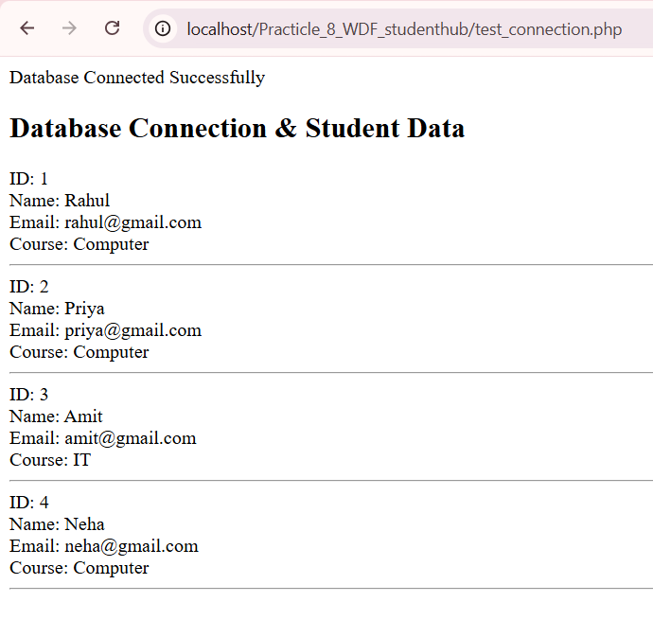

Output :

Learning outcome :

